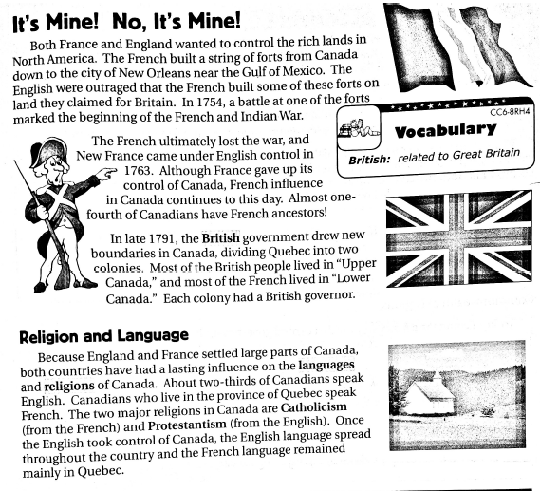

French and Indian War Brainpop – https://www.brainpop.com/socialstudies/ushistory/frenchandindianwar/

