Directions: Read the following text. Answer the questions. You can answer in answer box or use Kami to write on PDF.

Canada’s History:

Though today the majority of Canadians are white, the land that is now “Canada” was first occupied for thousands of years by the aboriginal peoples of North America. These people had lived on the northern half of the North American continent ever since homo sapiens first arrived from Asia, most likely via the Bering Land Bridge, around 21,000 B.C.
Over the centuries, North America’s indigenous peoples, also known as Indians, Amerindians, Native Americans, or First Nations, lived in small, nomadic groupings across all parts of modern Canada, even extremely inhospitable areas like the barren central grasslands and northern arctic. Over the course of the centuries, these communities developed into organized societies that, although technologically simple by today’s standards, nevertheless maintained sustainable economies, sophisticated political systems, complex spiritual beliefs, and rich, vibrant cultures.

Native American Videos:
Inuit: https://www.brainpop.com/socialstudies/ushistory/inuit/
Iroquois – https://www.brainpop.com/socialstudies/ushistory/haudenosauneeiroquoisconfederacy/

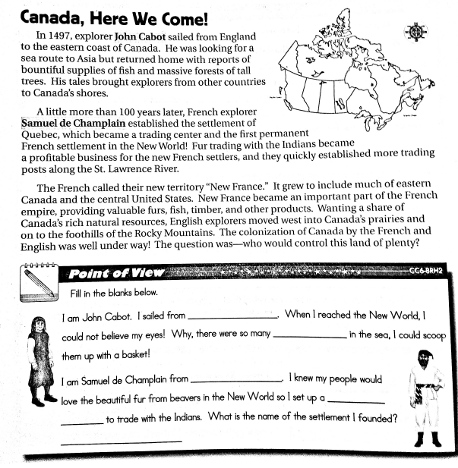
Henry Hudson – https://www.brainpop.com/socialstudies/famoushistoricalfigures/henryhudson/

Answer the 6 fill in the blanks

