Today we are taking time to examine the people who contributed to the early development of Canada and whose influence can still be seen today on the country.

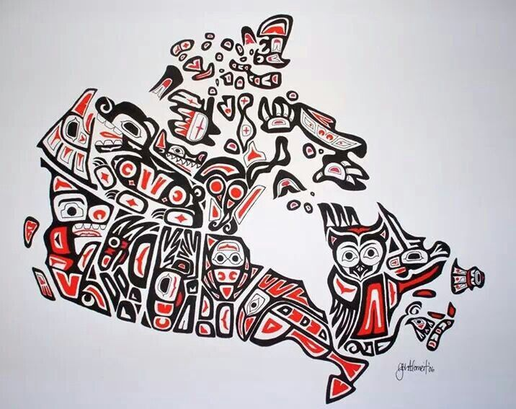

Though today the majority of Canadians are white, the land that is now “Canada” was first occupied for
thousands of years by the aboriginal peoples of North America. These people had lived on the northern
half of the North American continent ever since homo sapiens first arrived from Asia, most likely via
the Bering Land Bridge, around 21,000 B.C.
Over the centuries, North America’s indigenous peoples, also known as Indians, Amerindians, Native
Americans, or First Nations, lived in small, nomadic groupings across all parts of modern Canada,
even extremely inhospitable areas like the barren central grasslands and northern arctic. Over the
course of the centuries, these communities developed into organized societies that, although
technologically simple by today’s standards, nevertheless maintained sustainable economies,
sophisticated political systems, complex spiritual beliefs, and rich, vibrant cultures.
Native American Videos:
Brainpop – Native American Culture https://www.brainpop.com/socialstudies/ushistory/nativeamericantraditions/

Inuit: https://www.brainpop.com/socialstudies/ushistory/inuit/
Iroquois – https://www.brainpop.com/socialstudies/ushistory/haudenosauneeiroquoisconfederacy/

STEP 1: Open the link below

https://www.thecanadianencyclopedia.ca/en/article/aboriginal-people

Read the intro paragraph and Who are Indigenous Peoples in Canada?

STEP 2: Scroll down to “List of Indigenous People in Canada”

Choose one of groups of Native Americans you think you would like to research and click on their name to open their webpage. (Some groups have more information than others, if you choose one that does not have a lot, go back and choose another)
Once you have chosen one of groups of Native Americans to study, answer the following questions and tasks.

You can also choose these groups and use brainpop to get your information.
Brainpop – Inuit
https://www.brainpop.com/socialstudies/ushistory/inuit/
Brainpop – Iroquois
https://www.brainpop.com/socialstudies/ushistory/haudenosauneeiroquoisconfederacy/

- What group did you choose?
- Where did they live in Canada?
- Give me three interesting facts you learned about your Native Americans?
A)
B)
C)
- How did the geography impact their lives?
- Find some pictures that represent your group you researched and paste them in. (If you cannot upload a picture, copy and paste the web address)

