DOCUMENT A
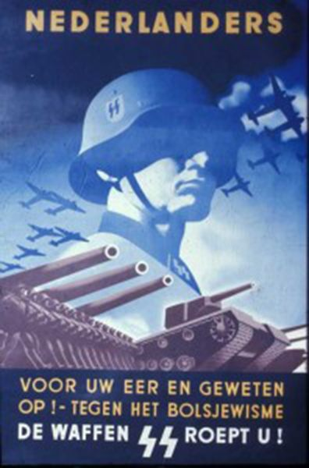

This poster hopes to recruit men from the Nazi-occupied Netherlands to the Nazi army. The passionate message at the bottom reads, "For your honor and conscience! Against the Bolshevism - the Waffen-SS calls you!"

DOCUMENT B
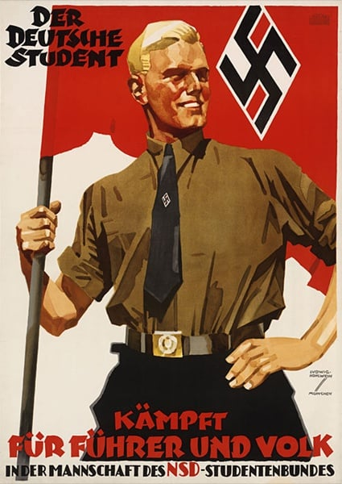
Here, a patriotic member of the Hitler Youth poses with the flag of the Nazi party. The text reads, "German students fight for the Fuhrer and the people."

DOCUMENT C
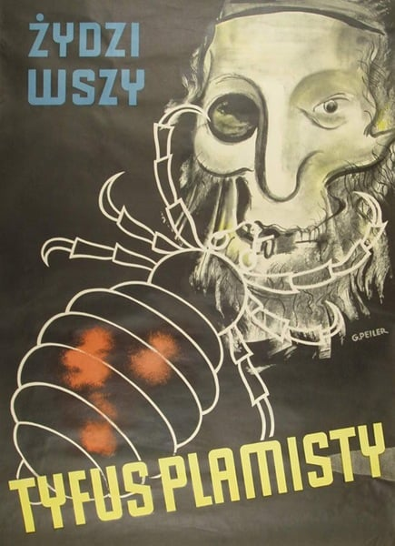
This poster, which reads "Jews are lice," was plastered across Poland, spreading fear that Jewish people carried typhus.

DOCUMENT D
Europe Pre and Post World War I
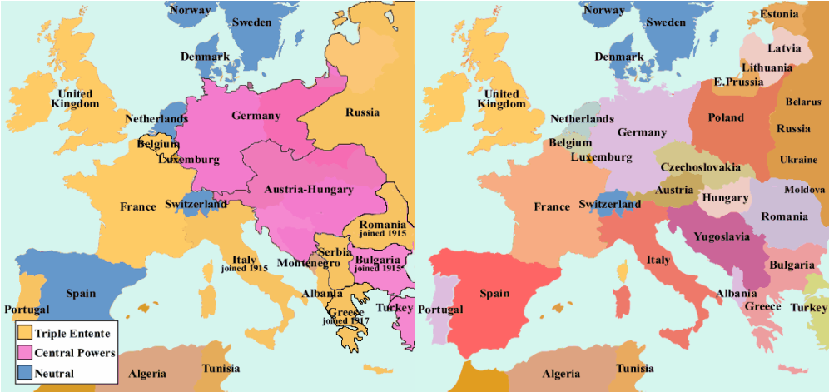

DOCUMENT E

Timeline of Significant Events

February 27, 1933: REICHSTAG (GERMAN PARLIAMENT) BUILDING DESTROYED BY FIRE
- Mysterious fire. Communists are blamed. Hitler convinces the German president, Hindenburg, to declare a state of emergency. Constitutionally protected personal freedoms are thus suspended.
MARCH 5, 1933: NAZIS FAIL TO WIN MAJORITY IN REICHSTAG ELECTIONS
- The Nazis win only about 45 percent of the vote. Later in March 1933, Hitler introduces a bill that would give his government the power to decree laws without submitting them to a vote
MARCH 23, 1933: THE REICHSTAG VOTES LEGISLATIVE POWER TO HITLER
- Adolf Hitler introduces “The Enabling Act”. Gives power to decree laws without a vote in parliament for a four-year period. Hitler soon outlaws all political parties in Germany--except the Nazi party.
JUNE 30, 1934: NIGHT OF THE LONG KNIVES
- More than 80 SA leaders (political opponents) are arrested and shot without trial. Hitler claims that the purge is a response to a plot by the SA to overthrow the government.
AUGUST 2, 1934 PRESIDENT VON HINDENBURG DIES AT THE AGE OF 87
- German president Hindenburg dies at age 87. Hitler takes over the powers of the presidency. Hitler's dictatorship thus rests on his position as Reich President (head of state), Reich Chancellor (head of government), and Fuehrer (leader of the Nazi party).

DIRECTIONS:

STEP 1:
Choose 3 of the 5 primary and secondary resources to examine.

STEP 2:
For each resource you choose – WRITE DOWN THE FOLLOWING
- What document is it?
- Classify - Is it a primary or secondary resource?
- Examine the resource for details. – Write down your description of what you see, (images, colors, shapes, phrases or symbols)

STEP 3:
- Explain how the resource connects to one of the following ways Nazism grew in power and how it would have helped them. This is more than a sentence answer.
.
A) Going against the Treaty of Versailles
B) Offering cures to the economic problems
C) Promoting strength and unity (nationalism)
D) Offering protection from enemies
E) Blaming Jews and promoting anti-Semitism

